

**Proposal for GoldFolks:**

**All-in-one Elderly Application**

**Anil Ankitha**

**Chan Shao Jing**

**Chong Yow Lim**

**Lionel Wong Zhi Neng**

**Low Jin Teng Jackson**

**Ng Chi Hui**

**Zachary Varella Lee Zheyu**

Team ElevenDegree

School of Computer Science & Engineering

Nanyang Technological University, Singapore

Submitted to—

Dr Althea Liang

School of Computer Science & Engineering

Nanyang Technological University, Singapore

Contents

Executive Summary 3

Statement of Problem 4

Customer Needs 5

Objectives 5

Technical Approach 6

Target Specifications 6

Technology Consideration 7

System Architecture/Platform 7

Project Management 8

Deliverables 8

Budget 9

Communication and Coordination with Sponsor 9

Team Qualifications 10

References 11

Appendix A: Résumés of Team Members 12

# Executive Summary

GoldFolks is a mobile application designed to be a companion to help the elderly age healthily and gracefully. It helps to remind the elderly of their medication needs, maintain and improve their cognitive ability through brain teasers and physical exercise.

Currently, while there are applications available that serve the various functions listed above, there is a lack of an all-in-one application. The elderly must install multiple applications and switch between them back and forth which can be troublesome and confusing at times.

Population aging is 21st century’s dominant demographic phenomenon and the need to have such an application becomes increasingly important. With this application, we aim to associate old age with good health, sense of well-being, and extended periods of productivity instead of illness, disability, and dependency.

To ensure user-friendliness, scalability, and a wide outreach, GoldFolks will be designed using the Flutter framework which will allow the application to be used on both Android and IOS devices.

As the saying goes, ‘Old is gold’, Team ElevenDegree is committed to developing an accessible, easy-to-use, all-in-one application to aid the elderly in Singapore to becoming GoldFolks.

# Statement of Problem

Aging populations are a problem faced by many countries. It was estimated that by 2035, around 32 percent of Singaporeans will be aged 65 and above. The median age is also expected to rise from 39.7 in 2015 to 53.4 in 2050 (Hirschmann, 2020). This means that Singapore will have an increasingly larger proportion of elderly in the future. Elderly people face a multitude of health problems, ranging from cognitive impairment like Alzheimer’s disease due to lack of mental stimulation to physical injury due to inactivity.

According to a study by the US Department of Health and Human Services, 55% of elderly are non-compliant with their prescription drug orders. This means they do not take their medication according to the doctor’s instructions due to various problems such as vision, memory loss, social isolation etc. When doses of medication are skipped or taken in the wrong amount, the results can be deadly and approximately 200,000 older adults in the US are hospitalized annually due to adverse drug reactions (Shabir, 2020).

The multitude of health problems coupled with the inability to adhere to medication instructions warrant constant care and support for the elderly, which costs time and money. However, the younger population may not be available to take care of their elderly parents around the clock due to low birth rates and a decreasing support ratio from 6.4 in 2010 to 3.8 in 2020 (Statista, 2021).

While there are nursing/retirement homes available, these may not be financially feasible options for some people. On top of that, many residents of such homes suffer from depression. Another study conducted in 2013 found that 21.1% of elderly nursing home residents have depression, with 14.4% suffering from minor depression and 6.7% suffering from major depression (Tiong et al., 2013). Notable factors found to be associated with depression included length of stay being longer than 2 years, known history of depression, pain, and lack of social contact. Depression has profound negative effects on quality of life and physical health, worsening the health of nursing home residents. Additionally, family members’ mental and emotional health suffer alongside residents. Nursing home staff and doctors also struggle to meet the needs of despondent residents.

Considering the issues highlighted above, there needs to be a way to help elderly people to monitor their own health and take care of themselves better in the comfort of their own home. This will reduce emotional and financial burden on the elderly as well as their loved ones.

## Preliminary Findings

Some members of our team have had experience caring for the elderly in nursing/retirement homes. At home, some of us take care of our grandparents. By speaking to the elderly and taking care of them through these experiences as well as researching online, we can identify their needs. Some common issues faced by the elderly that we aim to address include:

* Forgetting to take medication
* Loss of memory and cognitive functions
* Lack of physical activity, leading to other health issues

# Objectives

This document proposes a mobile application GoldFolks, with the following objectives:

1. **Reminding users of their medication –** Users will be able to enter their medications, the dosage, and the time in which they are supposed to take each medication. They can also upload a picture of their medication if they have multiple medications to take at different timings. The mobile app will trigger an alarm at the timings which the users have indicated and display the image uploaded along with the appropriate dosage. A probable future improvement to this function would be to link up with the hospital/clinic prescription system such that the medications can automatically be inputted into our application.
2. **Maintaining cognitive health through mental games –** There will be a games section available in our mobile app which consists of a few mini-games or brain teasers to help the elderly stimulate and keep their neurological functions active. The games should be easy to understand and intuitive such that it is compatible for elderly people who may not be technologically savvy.
3. **Improving physical well-being via exercise videos** – Our app will also consist of an exercise section which will contain videos of different workout routines suitable for the elderly. The videos should be sorted based on the difficulty level and length of the video so that it is easy for the elderly to choose the appropriate level of exercise based on their physical ability.

# Technical Approach

The application will be designed for use on mobile devices, which will be able to provide convenience and portability, which are important requirements for the elderly to monitor their health on the go. At the same time, mobile applications allow users to access certain features without an Internet connection. Additionally, the app should be user-friendly as the target audience, elderly, may not be technologically savvy.

## Target Specifications

GoldFolks will have 3 different tabs/sections for games, exercises, and reminders. The games section will have various games, such as Mental Math and Simon Says, that are designed to train users’ memory and cognitive abilities. The application will keep track of users’ scores and encourage them to achieve better scores over time.

The exercise section will consist of a list of exercises accompanied by step-by-step instructions. There will also be instructional videos to demonstrate the exercises. This will make it easier for the elderly to engage in simple physical exercises to keep active at home.

The reminders section allows users to set reminders that will notify them to take their medication. Users can set the frequency of each reminder and the dates at which each reminder will cease appearing. This way, the elderly will not forget to take their medication, which prevents their health from worsening.

By consolidating multiple relevant features into a single application and presenting them in a user-friendly manner, multiple needs of users can be met simultaneously.

## Technology Consideration

**Table 1:** Technologies used for the development of the application.

|  |  |
| --- | --- |
| **Technology** | **Description** |
| Flutter | An open-source UI software development kit created by Google for cross-platform mobile and web application development. |
| Firebase | Google’s backend-as-a-service (BaaS) platform with features that can be tuned to power the back end. |

## System Architecture/Platform

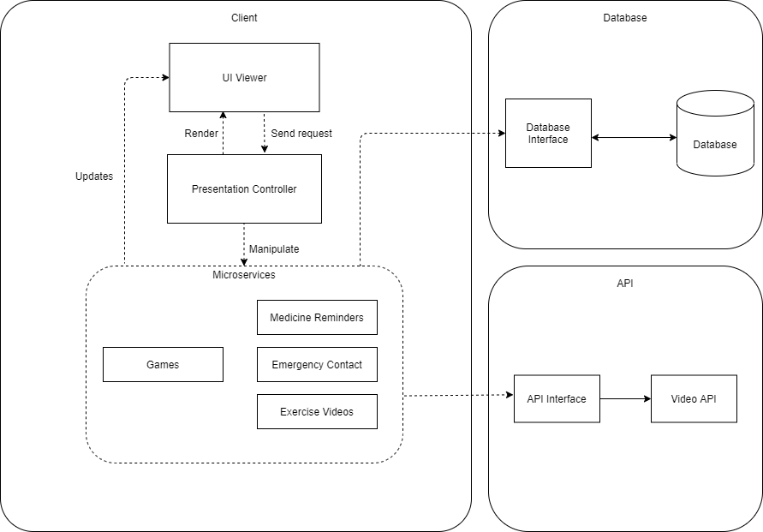

**Figure 1:** Initial draft for the system architecture of the project. (Refer to Diagrams-System Architecture.png in MediaWiki page for enlarged version)

We will be using several software tools for version control and documentation as listed below. These tools will help to expedite the documentation process. Additionally, we will be using Android Studio in combination with Flutter to develop the application platform.

**Table 2:** Platforms/tools used.

|  |  |
| --- | --- |
| **Platform/Tool** | **Description** |
| GitHub | Collaborate project code |
| Tortoise SVN | Prototype releases |
| Diagrams.net | System Architecture diagram |
| Visual Paradigm | Diagrams |
| Figma | Vector graphics editor and prototyping tool |
| Android Studio | IDE for Android app development |
| Trello | Managing backlog information |
| Team Gantt | Gantt Chart tool |
| MediaWiki | Structured documentation database |

# Project Management

We have chosen the **Agile** development methodology over the traditional Waterfall method to develop our mobile application to emphasize the rapid delivery of our application in complete functional components. Due to the independent nature of our individual functionalities, it will be more efficient for us to split the development of each functionality for sprint planning. The following is our project timeline for the project deliverables displayed in a Gantt chart format.

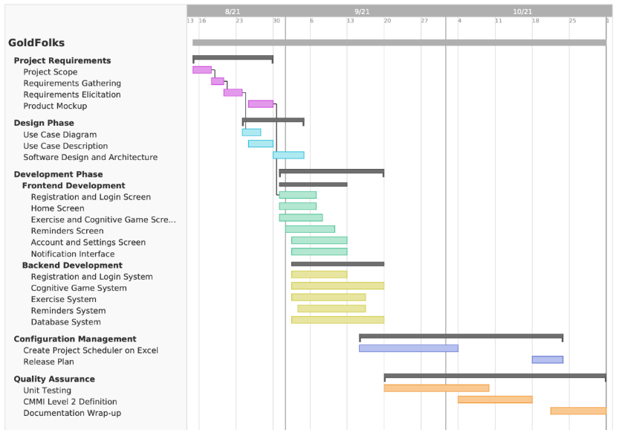

**Figure 2:** Gantt chart for the project. The solid bars indicate the portions of the tasks that we have accomplished. (Refer to Gantt Chart.pdf in MediaWiki page for enlarged version)

## Deliverables

In this section, we will go in depth to explain the details behind each of our deliverables.

1. **Detailed requirement specifications** – Detailed use-case model, use-case descriptions and software requirements documentation.
2. **Analysis Models** – Diagrams for database structure, class diagrams, software architecture, and relevant sequence diagrams.
3. **Database (Back-End)** – Cloud configured database on Google Firebase.
4. **Technical Prototypes (Front-End)** – Android mobile application prototype.
5. **Computer Program Code** – The implementation of the project plan following the documentation and diagrams.
6. **Project Documentation** – The full documentation, including the documentation of the program code and wiki using MediaWiki.
7. **Entire System** – the release product as according to the required specifications.
8. **Management Plans** – Configuration Management, Change Management, and Release Management plans.
9. **Quality Assurance Plan** – Documentation detailing the software quality plan.
10. **Test Procedures** – The description of the test cases and results.

## Budget

We have presented the breakdown of the monthly estimated costs of our project in the following table. The table will cover most of the major costs, from the salaries of the employees working on the project to the infrastructure costs such as equipment and rental of offices. In addition, there is an optional cost of transportation for periodical presentation of the application software to our clients.

**Table 3:** Monthly Estimated Costs of Project

|  |  |  |  |  |
| --- | --- | --- | --- | --- |
| **Item** | **Supplier** | **Quantity** | **Unit Price (SGD)** | **Total** |
| Project Manager | - | 1 | $8,000.00 | **$8,000.00** |
| Software Developers | - | 3 | $5,000.00 | **$15,000.00** |
| QA/Release Engineers | - | 3 | $4,000,00 | **$12,000.00** |
| Computers | Dell | 5 | $1,000.00 | **$5,000.00** |
| Computers | Apple | 2 | $1,400.00 | **$2,800.00** |
| Printer | HP | 1 | $3,000.00 | **$3,000.00** |
| Technology License | Android | 1 | $25.00 | **$25.00** |
| Technology License | Apple | 1 | $99.00 | **$99.00** |
| Back-end Services | Google | 1 | $2,000.00 | **$2,000.00** |
| Database | Google | 1 | $2,000.00 | **$2,000.00** |
| Office rental | NTU | 1 | $5,000.00 | **$5,000.00** |
| Transportation | Taxi | 1 | $300.00 | **$300.00** |
|  |  |  | **TOTAL** | **$55,224.00** |

## Communication and Coordination with Sponsor

Communication and coordination with our sponsors are key aspects to our project lifecycle. All updates regarding the project will be communicated to the sponsor’s point of contact on a weekly basis every Friday via email through our Project Manager. If a Friday falls on a holiday, the updates will be communicated the following Monday.

Sponsors will be required to acknowledge the information within 3 working days upon receipt and they should provide any feedback as well as raise any concerns, e.g., change in deadlines, feature request, etc., within this period.

Should there be any concerns raised, our Project Manager will schedule a meeting with the sponsor for the following Friday, unless specified by the client. As COVID-19 restrictions are still in place, all meetings will take place via Microsoft Teams until further notice.

## Team Qualifications

**Table 4:** Team qualifications.

|  |  |
| --- | --- |
| Name | Experience |
| Chan Shao Jing  (Project Manager) | Shao Jing has a rich history with managing software projects over the years as a Project Manager. He has successfully led his teams and delivered game-changing applications in the market which has time and time again proven to better the lives of his target audience. His technical and soft skills have been validated by his many clients that worked with him in the past. |
| Zachary Varella Lee Zheyu  (Lead Developer) | Zachary has hands-on experience technologies such as Flutter and Firebase. He has had experience managing teams of developers throughout his course at NTU and in the working world. |
| Anil Ankitha  (Front-end Developer) | Creative and motivated, Ankitha is an aspiring front-end software developer with experience in software such as Flutter, Firebase, Android Studio and HTML/CSS. Leading projects that are solution to real world problems, she has additional experience in managing groups for ultimate productivity. |
| Chong Yow Lim  (Back-end Developer) | Yow Lim has substantial experience with penetration testing and development of software projects. He is also well-versed in technologies like Node.js, Django, and Microsoft PowerApps. |
| Low Jin Teng Jackson  (QA Manager) | Leading several QA teams, Jackson has experience in software and system automation in various organizations. He is a motivated individual who can work well with others. |
| Lionel Wong Zhi Neng  (QA Engineer) | Lionel has substantial experience with performance and security testing. As a system QA and automation engineer, he has experience with functional testing via grey-box and white-box methodologies, testing it on computing languages such as Python, Flutter, Java and C. |
| Ng Chi Hui  (Release Engineer / Manager) | Chi Hui has substantial experience with quality assurance and software testing. Working at several startups, she has had experience working in various teams from data analytics to software and system testing. Her experience with cross-functional teams would certainly help in ensuring the quality and success of the product. |

# References

Hands, A. (2020, November 18). *Is it dangerous to leave your elderly parents home alone?* Assisting Hands Home Care - Lombard, Addison, Elmhurst & Surrounding Areas. https://assistinghands.com/70/illinois/lombard/blog/is-it-dangerous-to-leave-your-elderly-parents-home-alone/.

Hirschmann, R., 2020. Aging population of Singapore - statistics & facts*.* Accessed 22 August 2021 fromStatista*. https://www.statista.com/topics/5821/ageing-population-of-singapore.*

Shabir, D. O. (2020, April 28). *Improving cognitive abilities in the elderly*. News. https://www.news-medical.net/health/Improving-Cognitive-Abilities-in-the-Elderly.aspx.

Tiong, W. W., Yap, P., Huat Koh, G. C., Phoon Fong, N., & Luo, N. (2013). Prevalence and risk factors of depression in the elderly nursing home residents in Singapore. *Aging & mental health*, *17*(6), 724–731. https://doi.org/10.1080/13607863.2013.775638

# Appendix A: Résumés of Team Members

The following pages present one-page résumés of the team members for this project.

**Chan Shao Jing – Project Manager**

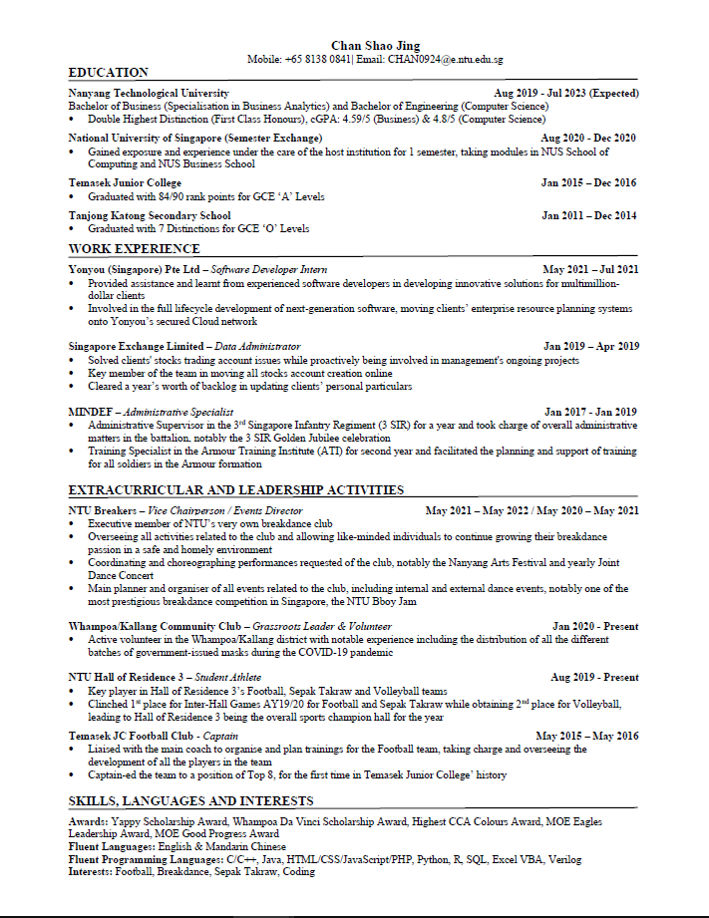

**Zachary Varella Lee Zheyu – Lead Developer**

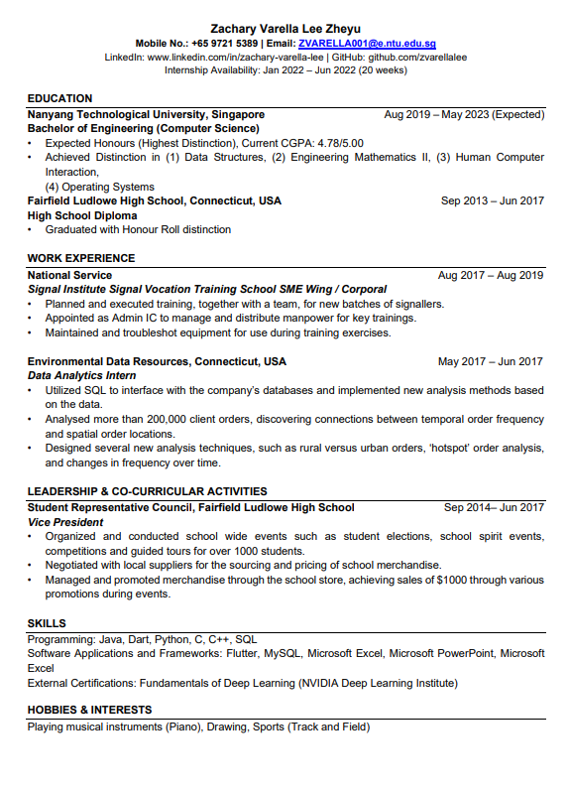

**Anil Ankitha – Front-End Developer**

**Chong Yow Lim – Back-end Developer**

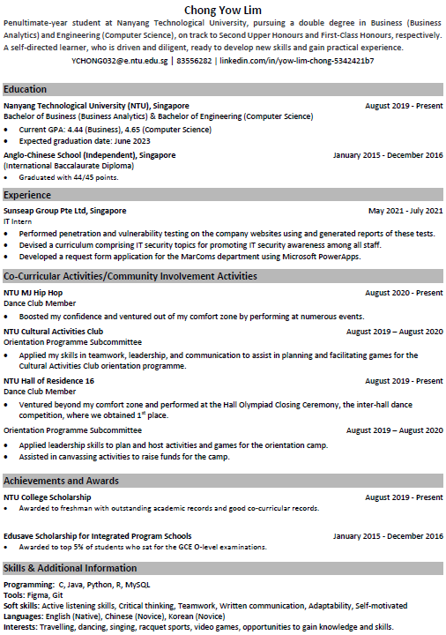

**Low Jin Teng Jackson – QA Manager**

**Lionel Wong Zhi Neng- QA Engineer**

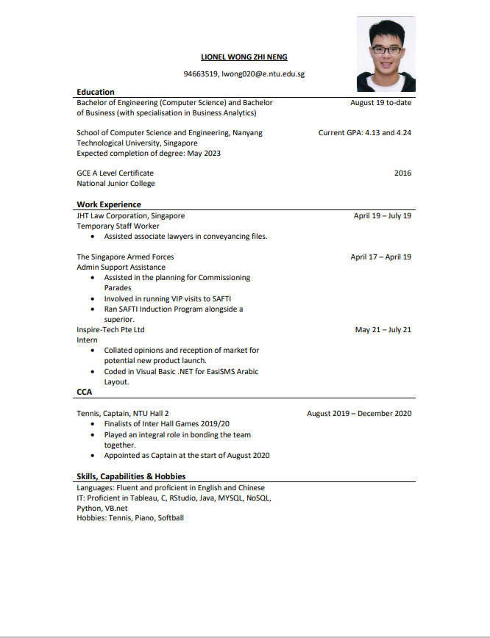

**Chi Hui – Release Engineer**

